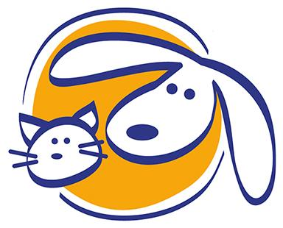

Client Information Sheet

Clayton Animal Hospital and North Main Animal Clinic

Client Information
Owner (Last Name, First): ___________________________________________________
Address: _________________________________________________________________
City: _________________________________ State: _______ Zip Code: _____________
Email Address: _____________________________________
Cell Phone: _____________________ Home Phone: ___________________
How did you learn about our practice?
Number of pets (Please specify by type):______________________________
Primary reason for visit: ___________________________________________

Patient Information
Patient Name: __________________________________ ☐ Cat ☐ Dog ☐ Other: __________
Sex: ☐ M ☐ F Neutered/Spayed: ☐ Yes ☐ No At What Age? ______ Birthdate: ___________
Breed: _______________________ What age was pet obtained? ________________________
From: ☐ Friend ☐ Breeder ☐ Humane Society ☐ Other: ______________________________
Describe your pet’s diet: ________________________________________________________
List your pet’s current medications: ________________________________________________
Please check any symptoms or problems you’ve noticed with your pet:
☐ Appetite Loss ☐ Gums Bleeding ☐ Urination Increase ☐ Depression ☐ Scratching
☐ Gagging ☐ Thirst ☐ Coughing ☐ Scooting ☐ Sneezing ☐ Breathing Problems
☐ Loss of Balance ☐ Weakness ☐ Shaking Head ☐ Behavioral Changes ☐ Limping
☐ Vomiting ☐ Diarrhea ☐ Other: ______________________________________
Pet’s History:
☐ Distemper ☐ Parvovirus (Dog) ☐ Rabies (Dog/Cat) ☐ Feline Leukemia Test
☐ FVRCP (Infectious Disease - Cat) ☐ Dental ☐ Other: ________________________
☐ Prior Surgery or Illness: __________________________________________________

Authorization
I hereby authorize the veterinarian to examine, prescribe for, or treat the above described pet. I assume responsibility for all charges incurred in the care of the animal. I also understand that ALL PROFESSIONAL FEES ARE DUE AT TIME SERVICES ARE RENDERED.
I authorize my pet’s picture to be used for North Main Animal Clinic or Clayton Animal Hospital media purposes ☐ Yes ☐ No

Signature of client responsible for pet(s): _________________________________ Date: ______
Please print this out and bring it to your appointment
or email us: patientcare@nmcvet.com

